

**Department of Computer Science and Engineering**

**Internet Technologies Lab – CSE 3262**

***Mini Project on***

**Payroll Management System - Django**

**Name: Bhavya Marupura**

**Register no: 210962168**

**Section: B**

**Roll no: 50**

**Department of Computer Science and Engineering**

**Manipal Institute of Technology, Manipal.**

**April 2024**

**PAYROLL MANAGEMENT SYSTEM - DJANGO**

**Abstract**:

The Django Payroll Management System is a web-based application designed to simplify and automate payroll-related tasks for organizations. This system provides an intuitive interface for administrators to manage employee information, process payroll, and handle employee complaints. Employees can sign up, view their details, and log complaints, improving communication and transparency within the organization. The system aims to streamline payroll management, reduce manual errors, and enhance overall efficiency.

**Introduction**:

Django, a popular Python web framework, provides a solid foundation for building web applications. It follows the MVC (Model-View-Controller) pattern, which helps in organizing code and separating concerns. Django's design philosophy revolves around reusability and pluggability, allowing developers to create complex, database-driven websites with ease.

The Django Payroll Management System leverages Django's capabilities to create a robust and efficient payroll solution for organizations. By harnessing Django's built-in features for authentication, database management, and user interfaces, the system provides a seamless experience for administrators and employees alike. Let's delve into the features of this system, highlighting how Django's framework enhances its functionality:

* Admin Login: Utilizing Django's authentication system, administrators can securely log in to the system to manage employee information and process payroll.
* Employee Signup: Django's form handling simplifies the process of employee registration, ensuring that new employees can easily sign up and access their payroll details.
* Employee Search: Django's ORM (Object-Relational Mapping) capabilities enable efficient searching of employee details, enhancing the system's usability for administrators.
* Complaint Logging: Django's form processing and database management features facilitate the logging of complaints by employees, ensuring that issues are recorded and addressed promptly.
* Complaint Viewing: Leveraging Django's templating system, both administrators and employees can view logged complaints, fostering transparency and accountability within the organization.

Overall, the Django Payroll Management System demonstrates the versatility and power of Django in building robust web applications that meet the specific needs of organizations.

**Literature Review:**

This overview offers a concise summary of selected papers in this field:

The provided information in the paper [1], underscores the critical role of payroll management within organizations, emphasizing its importance in accurately compensating employees and ensuring compliance with regulatory standards. Despite its significance, there seems to be a dearth of academic research comparing payroll processes to other transactional systems. However, there's recognition of the necessity for payroll systems in recording employee data and financial information, along with the advent of automated software solutions to streamline operations. Employee input is highlighted as essential for enhancing software efficiency, with suggestions ranging from provident funds to tax considerations. Integration with HR techniques, exemplified by GreytHR, is portrayed as pivotal for effective enterprise resource management. Furthermore, the vast amount of HR market data suggests the need for sophisticated information scanning methods to derive actionable insights for company decision-making.

The author in his study [2], introduces a Payroll Management System developed using the Django framework, highlighting its comprehensive functionality covering CRUD operations for employee, company, voucher, payroll, logs, and general settings. Emphasizing its role-based access control, the system allows administrators to execute any operation on the data. The author underscores the system's utility in managing employee salaries and company features, positioning it as an accessible project for Django beginners to enhance their web development skills. Built with Django in the backend and HTML/CSS in the frontend, the system boasts a fully-featured user interface. Additionally, the author encourages customization to suit individual needs, inviting feedback to improve the project and foster community collaboration.

The author presents a solution to the manual management challenges of employees' salaries, especially prevalent in regions like the Kurdistan Region of Iraq in his research [3]. They introduce a web-based Payroll Management System (WPMS) designed to streamline salary calculations, record-keeping, and report generation. Utilizing HTML, PHP, JavaScript, jQuery, AJAX, and MySQL, the system efficiently computes monthly and annual salaries, while also maintaining detailed records of pay, allowances, and deductions. Noteworthy features include a user-friendly interface, encrypted user passwords for security, and role-based access control to ensure data integrity. The system's flexibility allows for easy integration of additional faculties and allowances as needed. Automation of reporting and auditing processes enhances efficiency, and high satisfaction scores (87.8%) from the System Usability Scale evaluation affirm the system's effectiveness in meeting the electronic salary management needs of academic institutions.

In this article [4], the author discusses the evolving landscape of education consulting, particularly in the context of career counseling and guidance for international students pursuing higher education. They identify three key drivers of change: the rise of "celebrity" entrepreneurs and private businesses introducing innovations to academic institutions, the entrance of education policy and service consultants from major corporations into the public education sector, and the proliferation of small businesses founded by individuals transitioning from public to private sectors. Additionally, the author proposes the implementation of a "Payroll Management System" as a solution to increase earnings while reducing staffing and equipment needs for LAN-based timekeeping and payroll systems. The software, developed using Asp .Net for the front end and Microsoft SQL for the backend database, is intended to streamline payroll processes, enhance efficiency, and replace manual record-keeping systems. This proposal reflects a response to the changing dynamics within the education consulting industry, aiming to optimize operations and adapt to emerging trends.

This study [5], delves into the implications of cloud computing for payroll management, focusing on HR managers' perspectives on its advantages. Through qualitative analysis of focused group discussions with HR managers from Indian companies, the study highlights the benefits of transitioning from traditional to cloud-based payroll systems, including enhanced efficiency and streamlined processes. The proposed 5A Model aims to support HR managers in effectively navigating these systems. Moreover, the author underscores the global trend of HR leaders embracing cloud technology to save costs, boost worker satisfaction, and facilitate smoother operations. Cloud computing is depicted as a catalyst for organizational growth, accelerating product development, improving workflow, and ultimately contributing to overall success. The study suggests further research to delve deeper into the impact of cloud computing on payroll management, emphasizing the need for empirical studies. Overall, the study provides valuable insights into the transformative potential of cloud computing in optimizing payroll processes and empowering HR teams for strategic endeavors.

In this paper [6], the author addresses the shortcomings of traditional Business Intelligence (BI) approaches and highlights the emergence of a new generation of BI tools, particularly data discovery tools, which promise increased flexibility, ease of use, and productivity at reduced costs and implementation time. The focus is on utilizing BI tools, particularly Excel dashboards, to enhance data visualization and analysis within enterprises. The author emphasizes the importance of understanding organizational needs and user expectations when designing Excel dashboards, highlighting three key areas: data integration, management, and dashboard design. Furthermore, the author underscores the importance of interaction with users and managers, data analysis, and advanced Excel skills in creating effective dashboards, positioning Excel dashboards as valuable business tools and learning projects for information workers to improve lifelong skills beyond Excel.

This study delves into the evaluation of internal control and payroll accounting systems within hospitals, utilizing a descriptive methodology for data collection and analysis. Through interviews with company stakeholders and examination of secondary sources such as organizational structures, the research uncovers a well-established payroll system characterized by clear functional separation across departments. Notably, the study concludes that the internal control mechanisms and accounting systems in place are adequate for informed decision-making regarding employee salaries and wages. Key findings include the utilization of the Bank Sumut transfer system for salary disbursement, effective implementation of internal control elements, and a well-defined organizational structure facilitating functional segregation. Overall, this research sheds light on the operational efficiency and decision-making processes related to payroll management within hospital environments. [7]

In this paper [8], the author investigates the impact of payroll tax planning on corporate innovation within China's listed companies from 2015 to 2020. Utilizing Stata software for panel data analysis, the study reveals a positive relationship between payroll tax planning and corporate innovation, suggesting that such planning can stimulate innovation by incentivizing suppressed salaries due to individual income tax. While enriching academic understanding in individual income tax planning and offering new insights into corporate innovation, the author acknowledges limitations in value assignment for payroll tax planning due to its complexity. Looking forward, the author advocates for further research in this area and emphasizes the importance of China realizing its innovation potential amidst global competition, while encouraging enterprises to prioritize employee benefits and foster a conducive environment for research and development innovations.

In this paper [9], the author introduces a Payroll Management System designed to automate manual processes and improve data accessibility and control. Developed using HTML, JSP, JavaScript, CSS, Java, and MySQL technologies, the system aims to streamline payroll management tasks, such as tracking employee pay, calculations, and management, while providing user-friendly access via a web interface. The administrator, with total control, can manage various aspects, including user accounts, designations, and pay rates. The system is positioned as suitable for smaller and mid-cap businesses, with potential for future enhancements such as additional security features and administrative controls. The proposed system also integrates with leave management and attendance tracking, offering redundancy through cloud-based data storage. Overall, the paper presents a comprehensive solution to payroll management, highlighting its potential for further refinement and expansion to meet evolving business needs.

In this study [10], the author emphasizes the widespread adoption of automated systems in successful companies to enhance efficiency and reduce errors. The research focuses on designing an automated attendance monitoring system using biometrics, specifically, fingerprint scanning technology, to alleviate the manual workload and errors associated with traditional attendance and payroll processes. Through the utilization of components such as a fingerprint scanner, microcontroller, Zigbee module, and LCD, the system aims to streamline attendance tracking and payroll computation. Implemented with Microsoft .NET technology and Microsoft SQL Server, the program facilitates seamless data management and processing. Through testing, the automated system successfully records employee attendance, wirelessly transmits data, and automates payroll computations, including deductions. This study underscores the transformative potential of automated systems in improving operational efficiency and accuracy within organizations, particularly in attendance and payroll management.

In this paper, the author discusses the significance of Employee Performance Management Systems (EPMS) in modern industries, particularly in streamlining human resource tasks and enhancing organizational efficiency. The EPMS software is portrayed as a crucial tool for consolidating employee data, improving HR management, and facilitating informed decision-making by managers to enhance company performance. With features encompassing recruitment, project management, payroll, attendance, performance evaluation, and more, EPMS is positioned as a comprehensive solution to complex HR challenges. The paper underscores the importance of proper implementation of EPMS for individual employee growth and organizational success, highlighting its role in mitigating human errors, ensuring data security, and fostering employee development. Overall, the study emphasizes EPMS as an indispensable tool for effectively managing HR functions and evaluating individual employee performance within the dynamic landscape of modern industries. [11]

**Research Gaps and Objectives:**

Despite the prevalence of payroll management systems, there are several research gaps that warrant further investigation. Firstly, existing systems often lack user-friendly interfaces, which can lead to inefficiencies and user frustration. Additionally, there is a lack of emphasis on the security of sensitive payroll data, posing potential risks for organizations. Furthermore, there is limited research on integrating advanced features, such as machine learning algorithms, to improve the accuracy and efficiency of payroll calculations.

This Django project aims to create a user-friendly payroll management system. It will provide administrators with an intuitive interface to efficiently manage payroll information. Secure authentication will be implemented to protect sensitive data. Employees will be able to securely sign up and access their payroll information. The system will include a search functionality for administrators to retrieve employee details by name quickly. Additionally, a complaint logging system will allow employees to raise payroll-related issues, with a feature for administrators to address these complaints effectively.

**Results and Discussions:**

**Architecture**:

The Django project follows the MVC (Model-View-Controller) architecture.

* Models: Define the structure of the database tables and handle data logic.
* Views: Handle the presentation logic and interact with the models and forms.
* Controllers: Handle the business logic and request processing.

Here's the entity-relationship diagram (ERD) for the project:

**Models:**

Employee:

Fields: Name (CharField), Email (CharField), Password (CharField), Position (CharField), Salary (IntegerField)

**Forms:**

NewFavForm:

Fields: new_favorite (CharField)

NewComplaintForm:

Fields: name (CharField), sender (EmailField), c_type (CharField), subject (CharField), message (CharField)

NewSearchForm:

Fields: query (CharField)

NewSignupForm:

Fields: Name (CharField), Email (EmailField), Password (CharField), Position (CharField), Salary (IntegerField)

**Home Page:**

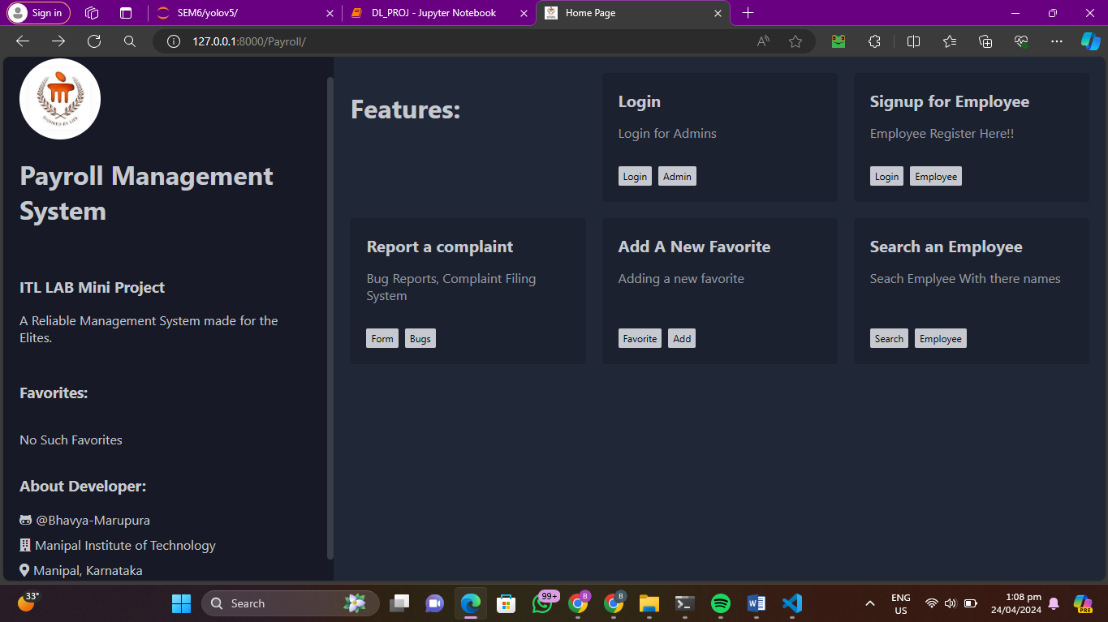

**Admin Login Page:**

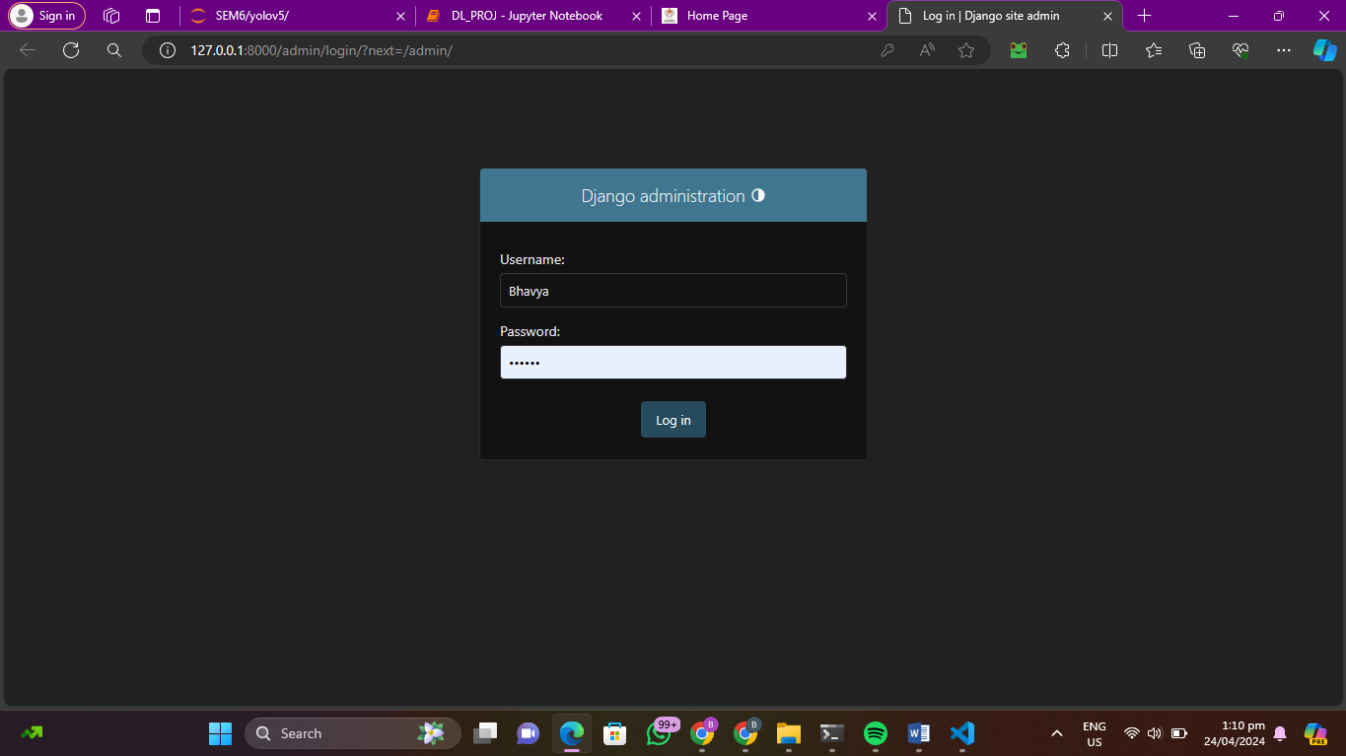

**Employee Sign-Up Page:**

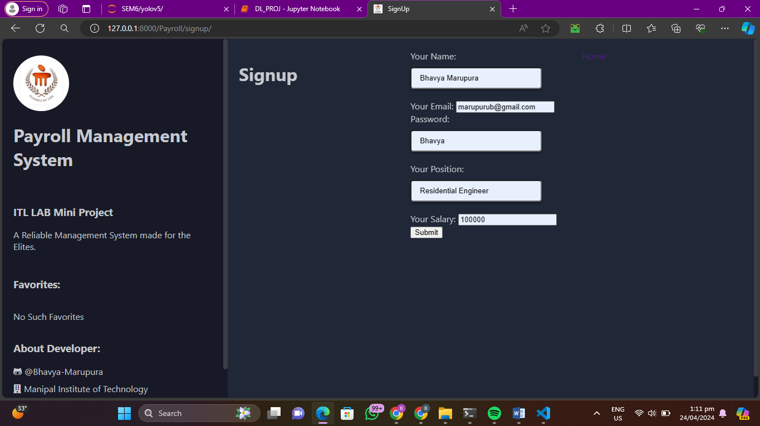

**Lodging a Complaint Page:**

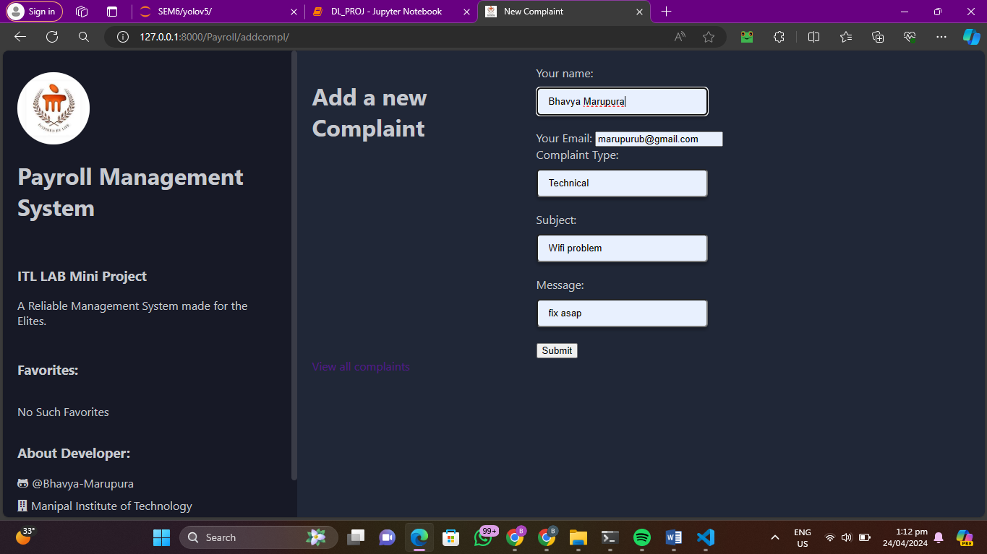

**View Complaint Page:**

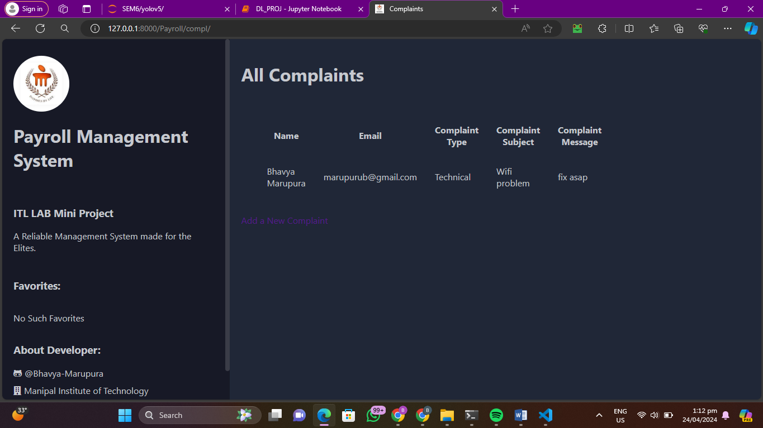

**Search Employee:**

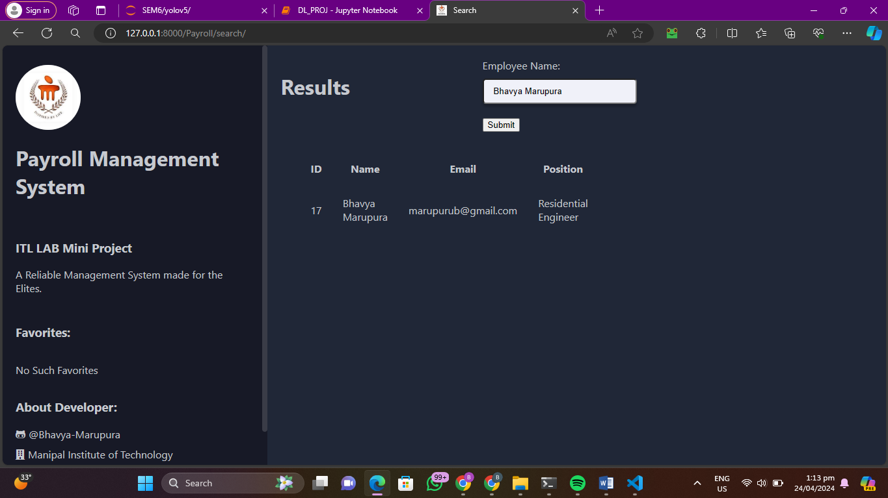

**Conclusions:**

In conclusion, the Django-based payroll management system has successfully achieved its objectives of providing a user-friendly and efficient platform for managing payroll information. The system's intuitive interface, secure authentication, and various features such as employee sign-up, complaint logging, and search functionality have significantly improved the payroll management process for organizations. The system has enhanced transparency, accessibility, and efficiency in managing payroll information, ultimately benefiting both administrators and employees.

**References:**

1. DESIGN AND IMPLEMENTATION: A REVIEW OF PAYROLL MANAGEMENT SYSTEM Tanya Aggarwal, Sakshi Tiwari, Dr Avneesh Kumar (Asso. Prof), Dr Sudeept Singh Yadav (Asso. Prof.), SCSE, Galgotias University, Greater Noida, Uttar Pradesh, India,2022 4th International Conference on Advances in Computing, Communication Control and Networking (ICAC3N)
2. Payroll Management System Project in Django, Joken Villanueva, Experienced software developer, content writer, and instructor, Mar 5, 2024
3. Ayah Mohammad Ahmed, Chira Nadheef Mohammed, Akeela Mustafa Ahmad, Web-based payroll management system, Department of Computer Science, University of Zakho, Zakho, Iraq, Journal of Electrical Systems and Information Technology volume 10, Article number: 17 (2023)
4. P. Ravi Teja, Rakesh Patra, A Study on Payroll- Management System Dept. of Business Administration, Koneru Lakshmaiah Hyderabad Global Business School Associate Professor, Dept. of Business Administration, Koneru Lakshmaiah Hyderabad Global Business School, International Journal for Multidisciplinary Research (IJFMR), Volume 5, Issue 1, January-February 2023.
5. Himani Choudhary, Deepika Pandita, Fatima Vapiwala, Aaradhana Rukadikar, Determining the Effectiveness of Cloud Computing on the Payroll Management System, Symbiosis Institute of Business Management, Pune, Symbiosis International (Deemed University), India, 2023 8th International Conference on Business and Industrial Research (ICBIR2023),18 - 19 May 2023, Bangkok, Thailand
6. Monika Arora, Dr. Deepankar Chakrabarti, Department of IT/IS, Application of Business Intelligence: A case on Payroll Management, Apeejay School of Management, New Delhi, India,2013 International Symposium on Computational and Business Intelligence.
7. Evaluation of Internal Control of Payroll System in Hospital, Melanthon Rumapea, Natalia Bagariang, Dimita Hemalli, Premasari Purba, Jamaluddin, Eviyanti Novita Purba, Dompak Pasaribu, Universitas Methodist Indonesia, Medan, Indonesia,2019 International Conference of Computer Science and Information Technology (ICoSNIKOM)
8. The Impact of Payroll Tax Planning on Corporate Innovation– Panel Data Analysis with Stata Jie Wu, Wuhan Business University, Wuhan, Hubei, China,2022 3rd International Conference on Education, Knowledge and Information Management (ICEKIM)
9. Novel Robust Payroll Management System for Micro, Small & Medium Enterprises Pardeep Kaur, Shivansh Sharma, Birinderjit Singh Kalyan, University Institute of Engineering Chandigarh University,2023 International Conference for Advancement in Technology (ICONAT) Goa, India. Jan 24-26, 2023.
10. Wireless Biometric Attendance Management and Payroll System, Jannyl Darren A. Villarama, John Paul Raphael O. Gernale, Don Airon N. Ocampo and *Jocelyn Flores Villaverd, Mapua University: School of Electrical, Electronics, and Computer Engineering *IEEE Member, Manila, Philippines.
11. Development of Employee Performance Management System Using Web-Based Application Vedangi Deshpande, Rushikesh Bhujade, Shivam Amin, Rahul Agrawal, Sachin Untawale, UG Student Department of Electronics Engineering G H Raisoni College of Engineering, Nagpur, India,2021 International Conference on Intelligent Technologies (CONIT) Karnataka, India. June 25-27, 2021